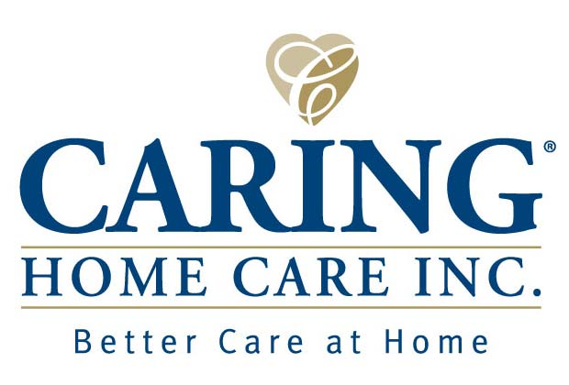 PERSONNEL REQUIREMENTS
ALL HOME HEALTH AIDES WILL BE REQUIRED TO PASS THE AHCA COMPETENCY EXAM IN ORDER TO BE CONSIDERED FOR CONTRACT (Orlando and Palm Beach HHA’s waived, as well as CNA’s, due to receiving competency exam upon certification)
- Home Health Aide Certificate (75hrs) or CNA License/Certificate
- For HHA’s: contact information to verify certificate with school
- Background Screen Level 2 (every 5 years) (Can’t have a 90 day break in services) If a new background /rescreening needs to be done (as of Jan. 2013) aide must have a picture taken to be entered into the Clearing House.
- OSHA certificate (annual)
- HIV/AIDS Certificate (required once)
- Alzheimer Certificate (biennial)
- Domestic Violence (biennial)
- Assist with Self –Administration of Medication Certificate (biennial and MUST have minimum of 2hrs.)
- Current physical within the last 6 months stating “free of communicable disease”.
- PPD (required biannually) or CXR, with physician documentation that no disease is present (both must be within the year for new applicants). A repeat CXR will be required every 3yrs.
- Current CPR (has to be done in a class- no online CPR will be accepted. Course must be approved by American Heart Association, American Red Cross, or American Safety and Health Institute).
- Social Security Card
- Proof of Residency or Citizenship (Work permit/Alien card)(Voter registration/Passport/Birth certificate or U.S citizen ID card)
- Driver License or Florida ID
- Professional Liability Insurance
- 2 verifications of employment OR one verification of employment & one reference letter
- Voided check
ALL DOCUMENTS MUST BE CURRENT PRIOR TO REGISTRATION.
If you have any questions in Dade or Broward call (954)734-1512
Once you have all of the above requirements, call Caring’s Human Resource Department in DADE: (954)734-1536 Broward: (954)734-1512 Boynton Beach: (561) 424-2477 Orlando: (407)499-4320 to schedule an appointment.

